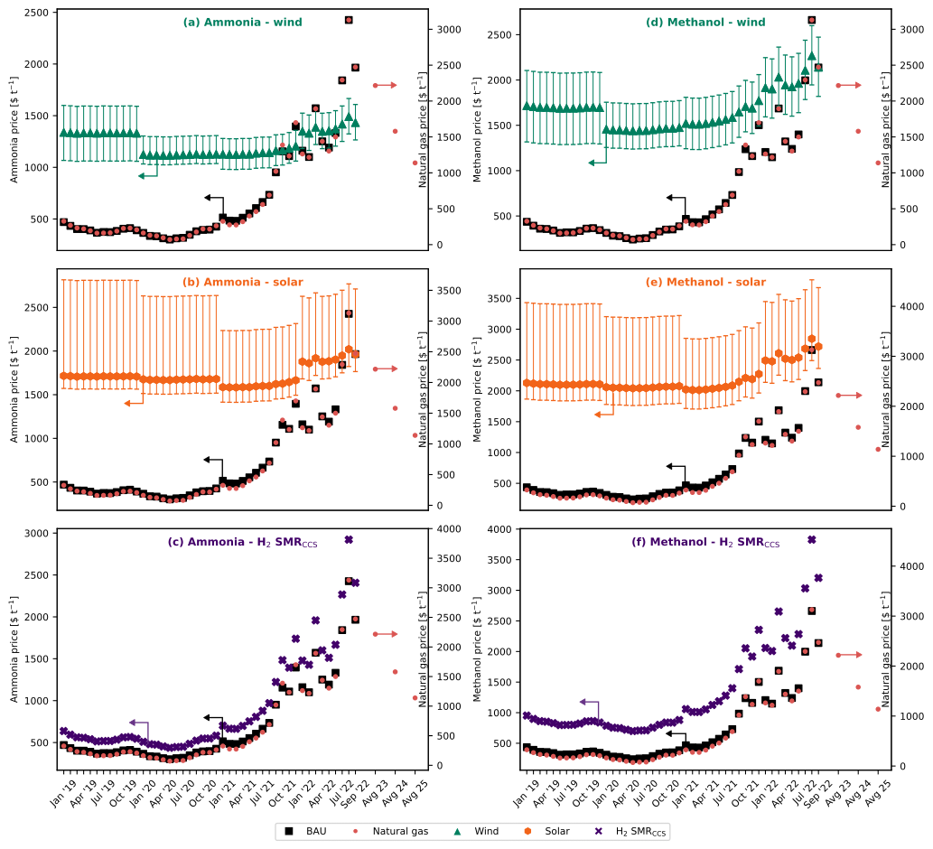
Fig. 1 (a) – (c) shows the production cost comparison of fossil (BAU) ammonia vs green ammonia with hydrogen from (a) water electrolysis using on-shore wind electricity, (b) water electrolysis using solar electricity, and (c) SMR + CCS. (d) – (f) shows the production cost comparison of fossil (BAU) methanol vs green methanol with hydrogen from (d) water electrolysis using on-shore wind electricity, (e) water electrolysis using solar electricity, and (f) SMR + CCS. The error bars in plots (a), (b), (d), and (e) are the sensitivity analysis due to the levelized cost of hydrogen (table 5). All the data points are shown in table 8 for ammonia and table 9 for methanol, respectively.
- In the past year, monthly average natural gas prices have increased from 560$ t⁻¹ in July 2021 to 2300$ t⁻¹ as of July 2022. Similarly, the price of grid electricity has almost quadrupled (table 1). The major reasons for this trend are the aftermath of COVID-19, soaring inflation, climate change, and war on Ukraine.
- In the case of BAU ammonia, every ton of ammonia produced consumes 0.53 ton of natural gas and 940 kWh of electricity. As of September 2022, cost of production for BAU ammonia was around 1965$ t⁻¹ which is three times higher in comparison to July 2021.
- When natural gas prices reach around 1400$ t⁻¹, ammonia with hydrogen from water electrolysis using on-shore wind electricity becomes cost competitive with BAU ammonia. Based on the monthly average natural gas prices, ammonia production via wind electrolysis has been cheaper than or similar to BAU ammonia for seven months since October 2021 (table 8).
- For ammonia, the solar scenario is only feasible around the peak of natural gas prices in August 2022. This can be attributed to lower capacity factors (16.1% to 17.5%) in comparison to wind electricity (35.6% to 39%) resulting in higher levelized costs of hydrogen.
- Hydrogen from SMR + CCS is always more expensive than BAU ammonia due to the inclusion of CCS and also the additional nitrogen feed required in this scenario. Whereas, in BAU ammonia the nitrogen comes from air used in the autothermal reformer.
- Looking at the current situation, natural gas prices are predicted to remain high (1579 – 2216$ t⁻¹) for the next few years. On the other hand, the prices of renewable energy technologies are expected to decrease. Therefore, ammonia production from wind could be the most promising technology in the foreseeable future.
- In the case of BAU methanol, every ton of methanol produced consumes 0.67 ton of natural gas and 708 kWh of electricity. Therefore, similar to ammonia, the cost of production for BAU methanol has increased sharply. In comparison to July 2021, the cost of production of methanol rose by 232% in September 2022.
- Methanol for the cases of hydrogen from water electrolysis using (d) on-shore wind, (e) solar, and (f) SMR + CCS, carbon dioxide from Direct Air Capture (DAC) is used as a feed. For every ton of carbon dioxide captured, 0.11 ton of natural gas is required.
- At natural gas prices of around 2475$ t⁻¹, the wind scenario is economically competitive in comparison to BAU methanol. Also, considering low prices of wind electricity, at natural gas prices of 1700$ t⁻¹, methanol production with hydrogen from water electrolysis using on-shore wind electricity and carbon dioxide from DAC is more feasible.
- The solar scenario for the production of methanol follows a similar trend to that seen for ammonia and is only feasible at the peak of natural gas prices (August 2022) considering low prices of solar electricity.
- For the case of hydrogen from SMR + CCS, the cost of production is on average 67.8% higher than BAU methanol due to additional cost of CCS and carbon dioxide from DAC.
- Similar to ammonia, methanol production via wind is expected to be cost competitive with BAU methanol in the coming future.

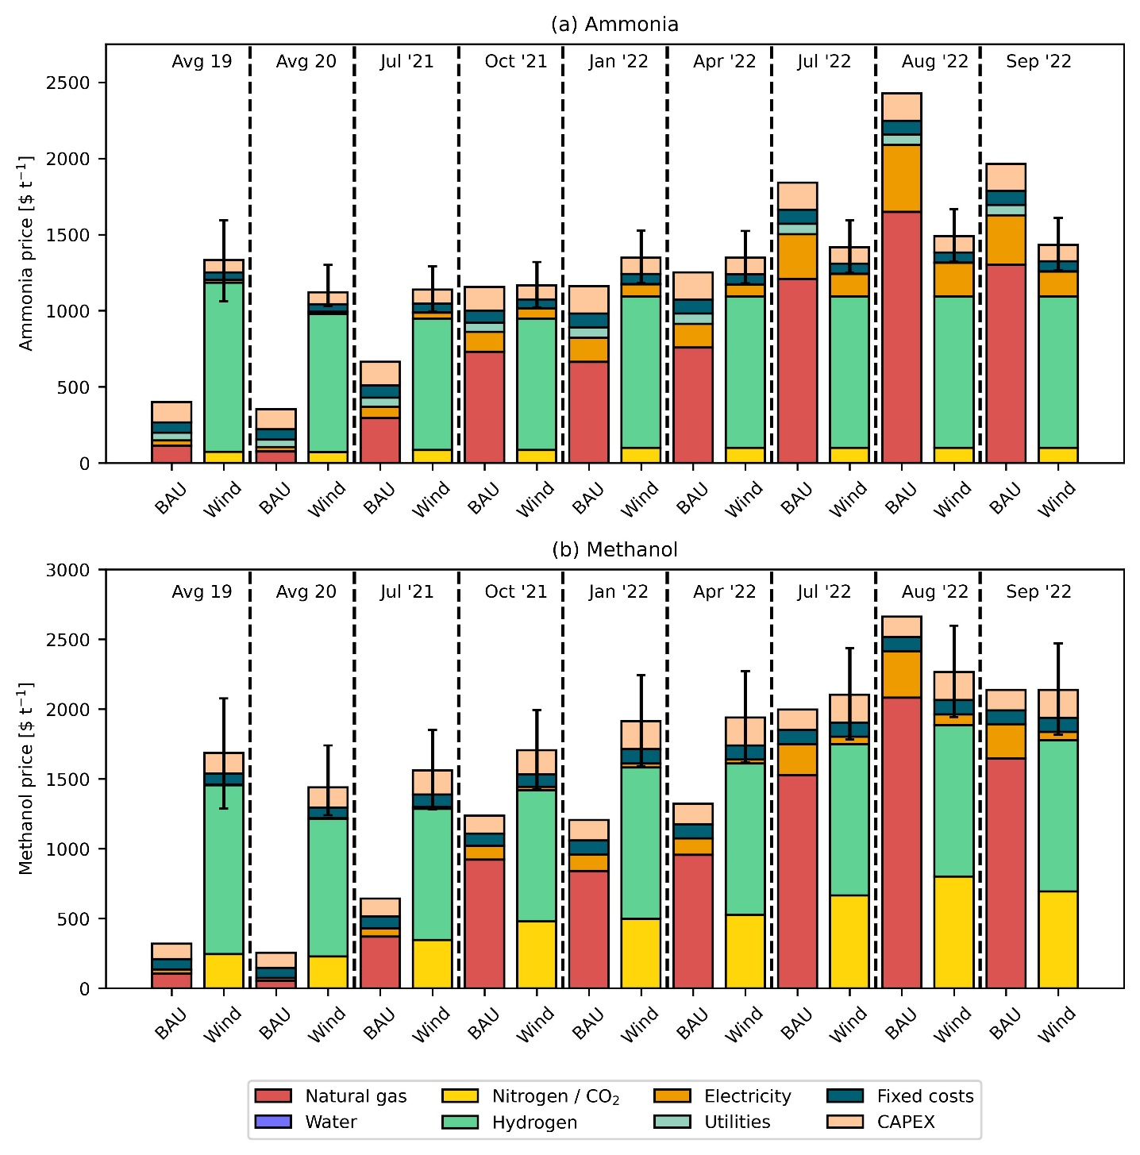
Fig. 2 Breakdown of production costs for (a) fossil (BAU) ammonia vs green ammonia with hydrogen from water electrolysis using on-shore wind electricity and (b) fossil (BAU) methanol vs green methanol with hydrogen from water electrolysis using on-shore wind electricity. The error bars are the sensitivity analysis due to the levelized cost of hydrogen (table 5).
- In Fig. 1, three hydrogen technologies were analyzed, namely, wind, solar, and SMR + CCS for the production of ammonia and methanol. It was found that the wind scenario is the most promising alternative that can be cost competitive with the BAU routes. Therefore, in Fig. 2, we compare the breakdown of production costs for the BAU and wind routes simultaneously for different months.
- Notably, for 2019 and 2020, we take average values for the breakdown calculations as the natural gas and electricity prices before July 2021 were approximately constant.
- For BAU ammonia, the contribution of natural gas to the production costs increased from 21.7% in 2020 (average) to 44.3% in July 2021. Further, the percentage share of natural gas increased to 66.3% in September 2022. Similarly, contribution of electricity increased from 8.1% in 2020 (average) to 16.5% in September 2022.
- Green hydrogen from wind electrolysis had the highest share (66.7% to 83.3%) for the production cost of green ammonia. Since wind electricity is used only for the electrolyzer, whereas, for the compressors we utilize grid electricity, the share of grid electricity rose from 1.3% in 2020 (average) to 11.4% in September 2022.
- Similarly for the production of BAU methanol, the share of natural gas increased from 32.3% in 2020 (average) to 57.8% in July 2021, and 76.9% in September 2022. Whereas, the contribution of electricity increased from 7.2% in 2020 (average) to 11.5% in September 2022.
- Hydrogen from wind electrolysis had the highest share of around 60.2% in July 2021 which decreased to 50.7% in September 2022 for the green methanol production route.
- The share of carbon dioxide from DAC for green methanol production was about 16.5% in 2020 (average) and increased to 32.5% in September 2022. This increase can be attributed to the increase in natural gas prices which is required for the capture of carbon dioxide (0.11 ton of natural gas per ton of carbon dioxide).

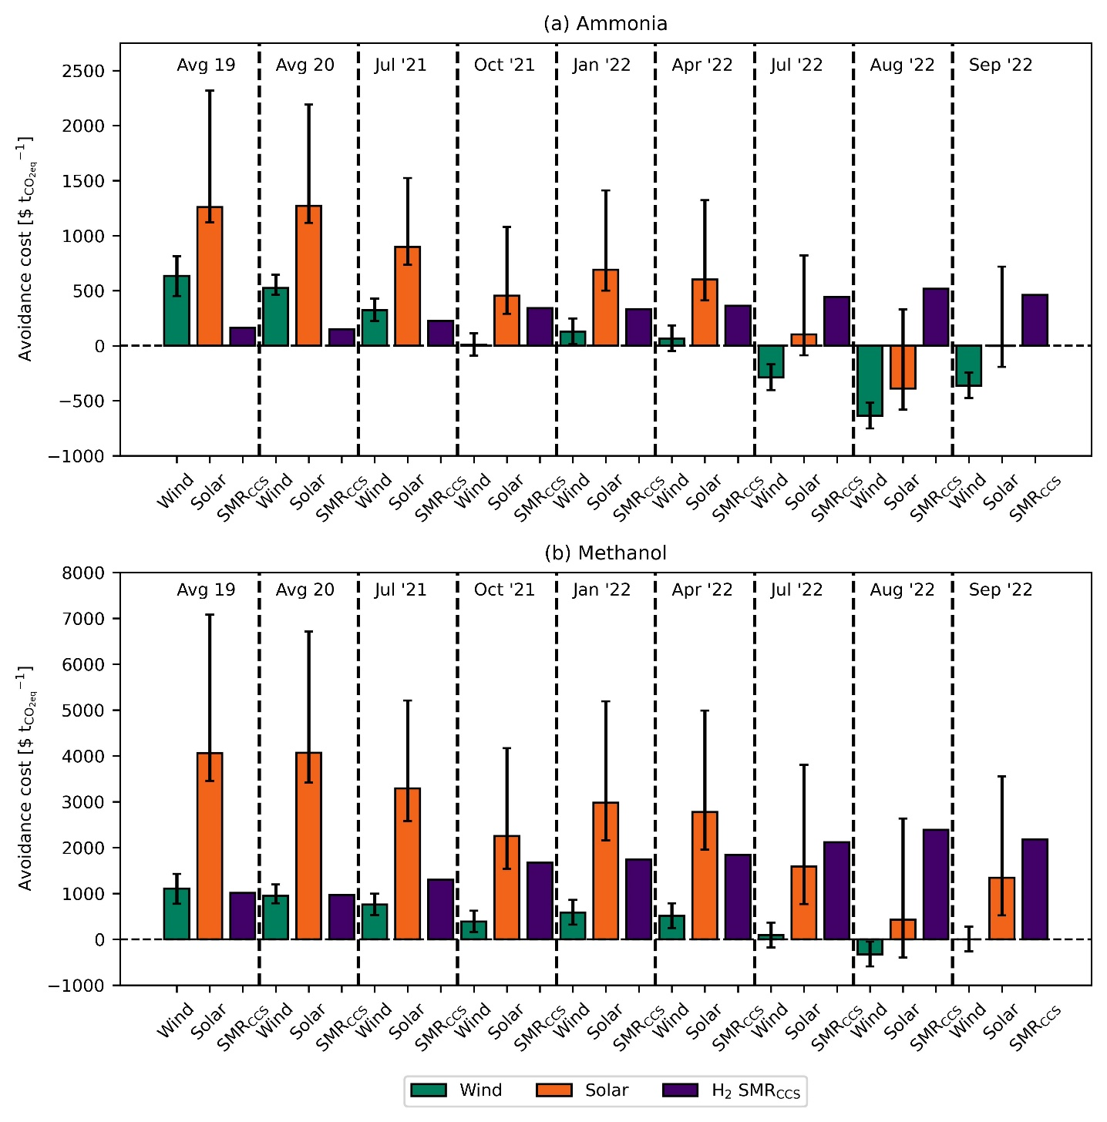
Fig. 3 CO₂ avoidance costs for (a) ammonia, and (b) methanol. The GWP values used are given in table 6 and table 7 for ammonia and methanol, respectively. The error bars are the sensitivity analysis due to the levelized cost of hydrogen (table 5).
- ${\text{CO}}_{\text{2}}\text{ avoidance costs =} \frac{{\text{P.C}}_{\text{alt}}\text{ -} {\text{P.C}}_{\text{BAU}}}{{\text{GWP}}_{\text{BAU}}\text{ -} {\text{GWP}}_{\text{alt}}}$
- ${\text{CO}}_{\text{2}}\text{ avoidance costs in \$} {\text{t}}_{{\text{CO}}_{\text{2}}\text{eq}}^{\text{-1}}$
- $\text{P.C is the production cost in \$ }{\text{t}}^{\text{-1}}\text{ of product}$
- $\text{GWP is the global warming potential in} {\text{t}}_{{\text{CO}}_{\text{2}}\text{eq}} {\text{t}}^{\text{-1}}\text{ of product}$
- $\text{alt are the alternative routes of production}$
- $\text{BAU is the business as usual route of production}$
- The avoidance costs follow an inverse relation to the natural gas price. As natural gas prices increase, we spend less money for every ton of carbon dioxide emissions avoided.
- Negative avoidance costs signify that the cost of production of BAU ammonia or BAU methanol are higher than the alternative route. As a result, we save money for every ton of carbon dioxide emissions avoided.
- Since July 2022, we save around 125$ to 638$ per ton of carbon dioxide emissions avoided by using the wind route for the production of ammonia. Similarly, in August 2022 for methanol via wind, savings stood at around 325$ per ton of carbon dioxide avoided.

Table 1 Average monthly prices of natural gas and electricity
Month | Natural gas  [$ t⁻¹] | Electricity  [$ MWh⁻¹]
Jan '19 | 326.18 | 49.41
Feb '19 | 268.54 | 42.81
Mar '19 | 231.45 | 30.61
Apr '19 | 219.83 | 36.97
May '19 | 193.92 | 37.83
Jun '19 | 160.41 | 32.50
Jul '19 | 161.75 | 39.71
Aug '19 | 164.43 | 36.82
Sep '19 | 188.11 | 35.77
Oct '19 | 226.09 | 36.95
Nov '19 | 230.11 | 41.00
Dec '19 | 206.43 | 31.97
Jan '20 | 162.20 | 34.98
Feb '20 | 130.02 | 21.91
Mar '20 | 121.53 | 22.52
Apr '20 | 94.73 | 17.05
May '20 | 70.60 | 17.60
Jun '20 | 78.19 | 26.23
Jul '20 | 80.43 | 30.07
Aug '20 | 127.79 | 34.89
Sep '20 | 176.49 | 43.68
Oct '20 | 218.49 | 33.96
Nov '20 | 216.26 | 38.80
Dec '20 | 261.84 | 43.55
Jan '21 | 324.84 | 52.79
Feb '21 | 275.24 | 48.71
Mar '21 | 273.90 | 47.18
Apr '21 | 319.48 | 53.66
May '21 | 398.12 | 53.33
Jun '21 | 460.22 | 74.13
Jul '21 | 558.97 | 81.29
Aug '21 | 689.44 | 82.81
Sep '21 | 1020.53 | 128.34
Oct '21 | 1387.37 | 139.54
Nov '21 | 1234.11 | 176.25
Dec '21 | 1699.25 | 220.96
Jan '22 | 1262.71 | 167.87
Feb '22 | 1216.69 | 128.78
Mar '22 | 1894.06 | 251.76
Apr '22 | 1438.75 | 166.00
May '22 | 1303.37 | 177.51
Jun '22 | 1499.52 | 218.18
Jul '22 | 2293.52 | 315.26
Aug '22 | 3129.51 | 469.35
Sep '22 | 2473.28 | 346.12

Table 2 Average CEPCI indexes
Year | CEPCI
2019 | 607.5
2020 | 596.2
2021 | 708.0
2022 (average till July) | 816.1

Table 3 Cost parameters used in economic calculations. All costs are presented in $_{2019.}
Component | Average | Low | High
Water [$ t⁻¹] | 0.18 | - | -
Cooling water [$ GJ⁻¹] | 0.38 | - | -
CO₂ capture and storage [$ t⁻¹] | 15.84 | - | -
CO₂ emissions [$ t⁻¹] | 30.00 | - | -
Nitrogen [$ t⁻¹] | 91.06 | - | -
Carbon dioxide – DAC [$ t⁻¹] * | 137.35 | 67.85 | 206.85
*These prices do not include the cost of natural gas required for the capture of carbon dioxide. 1 ton of carbon dioxide requires 0.11 ton of natural gas.

Table 4 Levelized cost of electricity in $ MWh⁻¹ and capacity factors (CF)
 | 2019 |  |  |  | 2020
 | Average | Low | High | CF | Average | Low | High | CF
Wind - on shore | 67 | 37 | 96 | 35.6 | 45 | 35 | 65 | 36.0
Solar PV | 68 | 52 | 190 | 17.5 | 57 | 39 | 163 | 16.1

 | 2021 |  |  |  | 2022
 | Average | Low | High | CF | Average | Low | High | CF
Wind - on shore | 42 | 26 | 59 | 39.0 | 48 | 30 | 68 | 39.0
Solar PV | 48 | 29 | 120 | 17.2 | 55 | 33 | 138 | 17.2

Table 5 Levelized cost of hydrogen in $ t⁻¹
 | 2019 |  |  |  | 2020
 | Average | Low | High | Average |  | Low | High
Wind - on shore | 6296 | 4761 | 7780 | 5138 |  | 4626 | 6162
Solar PV | 8444 | 7625 | 14688 | 8278 |  | 7357 | 13703

 | 2021 |  |  |  | 2022
 | Average | Low | High | Average |  | Low | High
Wind - on shore | 4894 | 4075 | 5764 | 5641 |  | 4697 | 6644
Solar PV | 7507 | 6534 | 11192 | 8653 |  | 7532 | 12900

Table 6 Global warming potentials in kg_{CO2eq} kg⁻¹ ammonia for all scenarios
Process | GWP
BAU | 2.180
Wind | 0.712
Solar | 1.140
H₂ SMR + CCS | 1.220

Table 7 Global warming potentials in kg_{CO2eq} kg⁻¹ methanol for all scenarios
Process | GWP
BAU | 0.658
Wind | -0.556
Solar | 0.226
H₂ SMR + CCS | 0.169

Table 8 BAU ammonia vs green ammonia. All prices are presented in $ t⁻¹. The values highlighted are the cases where the alternative route for ammonia production is cheaper than or similar to (not more than 5%) BAU ammonia.
 | Natural gas | BAU | Wind | Solar | SMR + CCS
Jan '19 | 326.18 | 470.06 | 1337.28 | 1715.73 | 636.94
Feb '19 | 268.54 | 433.53 | 1334.18 | 1712.63 | 593.64
Mar '19 | 231.45 | 402.59 | 1328.45 | 1706.90 | 562.04
Apr '19 | 219.83 | 402.42 | 1331.44 | 1709.89 | 556.93
May '19 | 193.92 | 389.57 | 1331.84 | 1710.29 | 539.25
Jun '19 | 160.41 | 366.93 | 1329.34 | 1707.79 | 513.38
Jul '19 | 161.75 | 374.38 | 1332.72 | 1711.17 | 517.70
Aug '19 | 164.43 | 373.09 | 1331.37 | 1709.82 | 518.21
Sep '19 | 188.11 | 384.58 | 1330.87 | 1709.32 | 534.23
Oct '19 | 226.09 | 405.69 | 1331.43 | 1709.88 | 561.28
Nov '19 | 230.11 | 411.60 | 1333.33 | 1711.78 | 565.99
Dec '19 | 206.43 | 390.68 | 1329.09 | 1707.54 | 545.23
Jan '20 | 162.20 | 365.51 | 1122.68 | 1675.93 | 508.60
Feb '20 | 130.02 | 336.34 | 1116.54 | 1669.79 | 480.02
Mar '20 | 121.53 | 332.43 | 1116.83 | 1670.08 | 474.39
Apr '20 | 94.73 | 313.20 | 1114.26 | 1667.51 | 453.12
May '20 | 70.60 | 301.00 | 1114.52 | 1667.76 | 436.55
Jun '20 | 78.19 | 313.08 | 1118.57 | 1671.82 | 445.90
Jul '20 | 80.43 | 317.84 | 1120.38 | 1673.62 | 449.27
Aug '20 | 127.79 | 347.30 | 1122.64 | 1675.89 | 484.56
Sep '20 | 176.49 | 381.17 | 1126.77 | 1680.02 | 522.66
Oct '20 | 218.49 | 394.21 | 1122.20 | 1675.45 | 547.39
Nov '20 | 216.26 | 397.56 | 1124.48 | 1677.73 | 548.11
Dec '20 | 261.84 | 426.00 | 1126.71 | 1679.96 | 582.13
Jan '21 | 324.84 | 514.22 | 1125.63 | 1586.07 | 701.49
Feb '21 | 275.24 | 484.28 | 1123.71 | 1584.15 | 664.98
Mar '21 | 273.90 | 482.14 | 1122.99 | 1583.43 | 663.33
Apr '21 | 319.48 | 512.21 | 1126.04 | 1586.48 | 698.16
May '21 | 398.12 | 553.32 | 1125.88 | 1586.32 | 752.85
Jun '21 | 460.22 | 605.49 | 1135.65 | 1596.09 | 805.95
Jul '21 | 558.97 | 664.20 | 1139.02 | 1599.46 | 878.18
Aug '21 | 689.44 | 734.34 | 1139.73 | 1600.17 | 969.90
Sep '21 | 1020.53 | 951.32 | 1161.13 | 1621.57 | 1222.22
Oct '21 | 1387.37 | 1155.02 | 1166.39 | 1626.83 | 1483.35
Nov '21 | 1234.11 | 1108.63 | 1183.64 | 1644.08 | 1393.70
Dec '21 | 1699.25 | 1395.45 | 1204.65 | 1665.09 | 1739.14
Jan '22 | 1262.71 | 1160.71 | 1347.78 | 1878.52 | 1478.44
Feb '22 | 1216.69 | 1099.90 | 1329.41 | 1860.15 | 1427.97
Mar '22 | 1894.06 | 1571.73 | 1387.20 | 1917.94 | 1958.21
Apr '22 | 1438.75 | 1251.69 | 1346.90 | 1877.64 | 1600.35
May '22 | 1303.37 | 1191.14 | 1352.31 | 1883.05 | 1511.33
Jun '22 | 1499.52 | 1332.50 | 1371.42 | 1902.16 | 1667.25
Jul '22 | 2293.52 | 1841.52 | 1417.04 | 1947.78 | 2266.66
Aug '22 | 3129.51 | 2426.00 | 1489.44 | 2020.19 | 2922.16
Sep '22 | 2473.28 | 1965.08 | 1431.54 | 1962.28 | 2406.54

Table 9 BAU methanol vs green methanol. All prices are presented in $ t⁻¹. The values highlighted are the cases where the alternative route for methanol production is cheaper than or similar to (not more than 5%) BAU methanol.
 | Natural gas | BAU | Wind | Solar | SMR + CCS
Jan '19 | 326.18 | 435.89 | 1715.69 | 2128.05 | 693.03
Feb '19 | 268.54 | 392.86 | 1705.26 | 2117.62 | 638.79
Mar '19 | 231.45 | 359.54 | 1697.20 | 2109.56 | 602.55
Apr '19 | 219.83 | 356.31 | 1696.40 | 2108.75 | 592.92
May '19 | 193.92 | 339.67 | 1692.35 | 2104.71 | 569.18
Jun '19 | 160.41 | 313.59 | 1686.03 | 2098.39 | 537.39
Jul '19 | 161.75 | 319.59 | 1687.47 | 2099.83 | 539.84
Aug '19 | 164.43 | 319.32 | 1687.41 | 2099.77 | 541.83
Sep '19 | 188.11 | 334.34 | 1691.06 | 2103.42 | 563.47
Oct '19 | 226.09 | 360.46 | 1697.40 | 2109.76 | 598.68
Nov '19 | 230.11 | 366.00 | 1698.74 | 2111.10 | 603.07
Dec '19 | 206.43 | 343.85 | 1693.38 | 2105.74 | 579.72
Jan '20 | 162.20 | 313.12 | 1456.16 | 2058.98 | 532.31
Feb '20 | 130.02 | 282.45 | 1448.75 | 2051.57 | 500.45
Mar '20 | 121.53 | 277.23 | 1447.48 | 2050.30 | 492.73
Apr '20 | 94.73 | 255.52 | 1442.22 | 2045.04 | 467.10
May '20 | 70.60 | 239.85 | 1438.41 | 2041.23 | 444.95
Jun '20 | 78.19 | 251.01 | 1441.10 | 2043.92 | 453.41
Jul '20 | 80.43 | 255.22 | 1442.11 | 2044.93 | 456.12
Aug '20 | 127.79 | 290.15 | 1450.58 | 2053.40 | 500.59
Sep '20 | 176.49 | 328.79 | 1459.94 | 2062.76 | 546.96
Oct '20 | 218.49 | 349.87 | 1465.09 | 2067.91 | 584.03
Nov '20 | 216.26 | 351.80 | 1465.54 | 2068.36 | 582.79
Dec '20 | 261.84 | 385.50 | 1473.71 | 2076.53 | 625.60
Jan '21 | 324.84 | 467.80 | 1520.55 | 2022.25 | 755.90
Feb '21 | 275.24 | 431.91 | 1511.84 | 2013.54 | 709.50
Mar '21 | 273.90 | 429.93 | 1511.37 | 2013.07 | 708.01
Apr '21 | 319.48 | 464.85 | 1519.83 | 2021.53 | 751.11
May '21 | 398.12 | 516.96 | 1532.49 | 2034.19 | 823.53
Jun '21 | 460.22 | 573.02 | 1546.05 | 2047.75 | 884.29
Jul '21 | 558.97 | 643.82 | 1563.23 | 2064.92 | 976.51
Aug '21 | 689.44 | 731.73 | 1584.58 | 2086.27 | 1097.01
Sep '21 | 1020.53 | 984.33 | 1645.80 | 2147.50 | 1409.86
Oct '21 | 1387.37 | 1236.43 | 1707.01 | 2208.71 | 1749.86
Nov '21 | 1234.11 | 1160.40 | 1688.43 | 2190.13 | 1614.81
Dec '21 | 1699.25 | 1501.64 | 1771.20 | 2272.89 | 2051.06
Jan '22 | 1262.71 | 1206.21 | 1914.42 | 2492.72 | 1708.09
Feb '22 | 1216.69 | 1147.91 | 1900.38 | 2478.67 | 1659.06
Mar '22 | 1894.06 | 1685.82 | 2030.68 | 2608.98 | 2304.16
Apr '22 | 1438.75 | 1322.07 | 1942.57 | 2520.87 | 1870.03
May '22 | 1303.37 | 1240.10 | 1922.63 | 2500.92 | 1747.19
Jun '22 | 1499.52 | 1399.45 | 1961.22 | 2539.51 | 1934.85
Jul '22 | 2293.52 | 1996.64 | 2106.00 | 2684.30 | 2683.05
Aug '22 | 3129.51 | 2662.15 | 2267.21 | 2845.51 | 3479.60
Sep '22 | 2473.28 | 2138.14 | 2140.28 | 2718.58 | 2853.95

